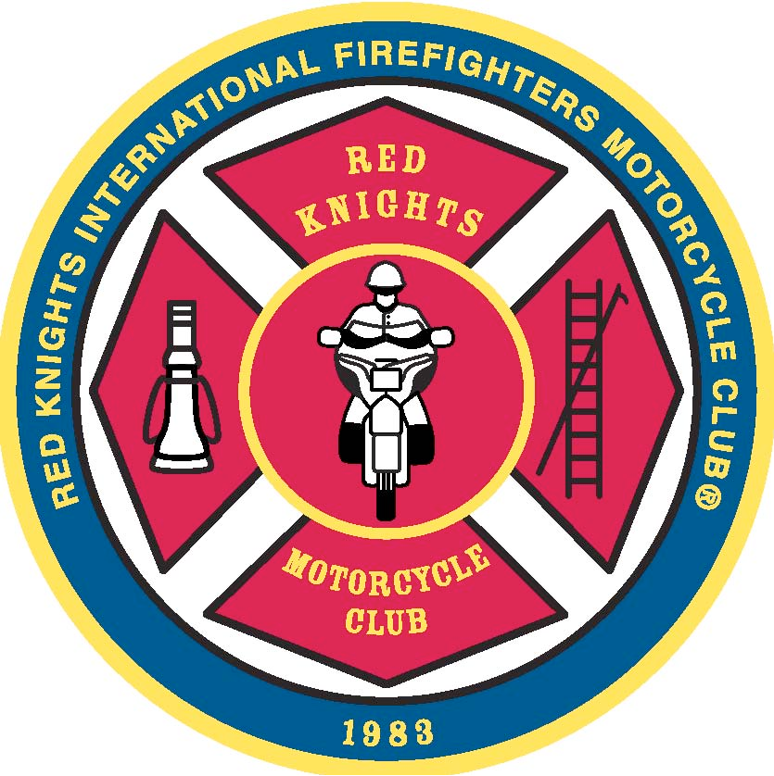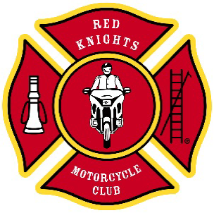

**Red Knights International Firefighters Motorcycle Club® Inc.**

**Office of the Region 7 Director**

**Tom van der Kley**

**0049 1709338932**

[**Region7@redknightsmc.com**](mailto:Region7@redknightsmc.com)

End of the year report

Dear Brothers and Sisters,

First of all I want to wish you all a happy new year and a good health.

The year 2022 has come to an end, and I can proudly look back at it and say that it was a successful year for our organization.

I was lucky to have been invited to a lot of gatherings, not only in Europe, but also on other continents. No matter where I have been, it was always the same feeling when I arrived at any location. It felt like home, it felt like family.

Looking back over all the hard work that each one of you made this year, I just can say that I am proud to be a member of this big family. Even when times were hard, tough decisions that had to be made, or conflicts that had to be solved, at the end we were all standing at the same end of the rope and we were pulling in one direction.

In September we will have one the most challenging events in Austria for this year. The International Convention 2023 will be hosted by Chapter Austria 4 and they are really looking forward to it. Less than 9 months prior to the convention, with hundreds of hours of preparations, with dozens of problems solved, the only thing that I can say is that Austria is well prepared and that they can’t wait the day to come. Already now, we have chapters from Europe, England, Canada, USA and Australia registered for the convention. This are more than 60 chapters from all over the world attending.

The European rally in Netherland was a huge success, and despite the rain, it was a rally with a lot of fun and a lot of memories that have been made. The chapter of Netherland 1 did an amazing job to make it an unforgettable weekend.

Unfortunately this year we had a couple of members that passed away. These are the hardest moments in a family, and I want to thank all the members that showed the last respect to the brothers. You cannot imagine how much that means to the family, brothers and sisters when you support them and show up to pay your respect. The condolences via all possible ways helps them to see even in the darkest moment a light sunshine.

For the next years coming I would love to see how we all getting a little closer together, concentrating more on the important things like brotherhood and family. Forget all the little differences and don’t waste your time on fighting. Use that energy to help each other, enjoying the moments, enjoying the brotherhood and just get on your bike and ride. Life is too short to waste time on things that could have easily been avoid by talking to each other.

I wish you all a good start in the new year, and I hope to see you at a couple of meetings, party`s, conventions or just on the road.

Fraternally

Tom van der Kley

Regional Director Region 7

Red Knights International Motorcycle Club®

**Loyal To Our Duty**